NAME : V.DEEPIKA

REG NO :732720121009

LINK :<https://wokwi.com/projects/305491191666836034>

SCREEN SHOT: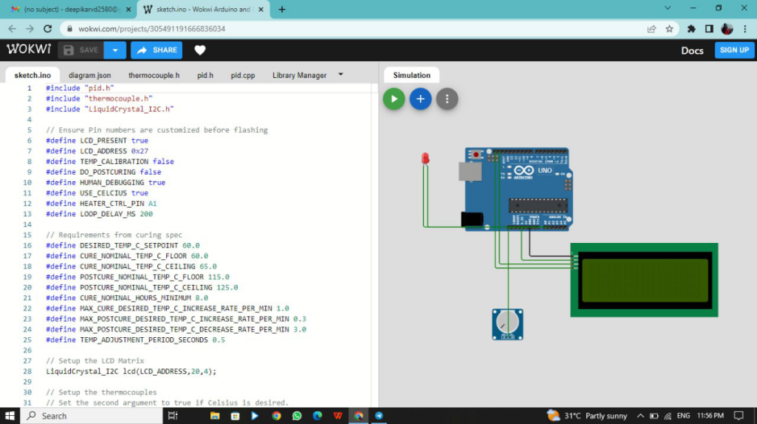

PROGRAM:

#include "pid.h"

#include "thermocouple.h"

#include "LiquidCrystal_I2C.h"

// Ensure Pin numbers are customized before flashing

#define LCD_PRESENT true

#define LCD_ADDRESS 0x27

#define TEMP_CALIBRATION false

#define DO_POSTCURING false

#define HUMAN_DEBUGGING true

#define USE_CELCIUS true

#define HEATER_CTRL_PIN A1

#define LOOP_DELAY_MS 200

// Requirements from curing spec

#define DESIRED_TEMP_C_SETPOINT 60.0

#define CURE_NOMINAL_TEMP_C_FLOOR 60.0

#define CURE_NOMINAL_TEMP_C_CEILING 65.0

#define POSTCURE_NOMINAL_TEMP_C_FLOOR 115.0

#define POSTCURE_NOMINAL_TEMP_C_CEILING 125.0

#define CURE_NOMINAL_HOURS_MINIMUM 8.0

#define MAX_CURE_DESIRED_TEMP_C_INCREASE_RATE_PER_MIN 1.0

#define MAX_POSTCURE_DESIRED_TEMP_C_INCREASE_RATE_PER_MIN 0.3

#define MAX_POSTCURE_DESIRED_TEMP_C_DECREASE_RATE_PER_MIN 3.0

#define TEMP_ADJUSTMENT_PERIOD_SECONDS 0.5

// Setup the LCD Matrix

LiquidCrystal_I2C lcd(LCD_ADDRESS,20,4);

// Setup the thermocouples

// Set the second argument to true if Celsius is desired.

#define THERMOCOUPLE_COUNT 5

Thermocouple t1(A0, USE_CELCIUS, 0.5);

Thermocouple t2(A0, USE_CELCIUS, 0.5);

Thermocouple t3(A0, USE_CELCIUS, 0.5);

Thermocouple t4(A0, USE_CELCIUS, 0.5);

Thermocouple t5(A0, USE_CELCIUS, 0.5);

Thermocouple thermocouples[THERMOCOUPLE_COUNT] = {t1, t2, t3, t4, t5};

// PID object params

double dt = 0.1; // loop interval time

double max_out = 1; // maximum allowable output from pid

double min_out = -1; // minimum allowable output from pid

double Kp = 0.01; // proportional gain

double Kd = 0.01; // derivative gain

double Ki = 0.5; // integral gain

// Create pid object with params

PID pid = PID(dt, max_out, min_out, Kp, Kd, Ki); // Not used at the moment.

// Variables for test/debug

double test_setpoint = 60;

// Varibles for the oven controller

float prev_temp;

unsigned long prev_meas_timestamp = 0;

unsigned long last_heat_adjustment_timestamp = 0;

unsigned long setpoint_reached_timestamp = 0;

unsigned long last_lcd_update_timestamp = 0;

bool update_setpoint_timestamp;

bool heater_on;

long votes_for_heat = 0;

double toFahrenheit(double celcius) {

return celcius * 1.8 + 32.0;

}

double toCelcius(double fahrenheit) {

return (fahrenheit - 32.0) / 1.8;

}

void setup() {

// put your setup code here, to run once:

Serial.begin(9600);

Serial.print("Serial started.\n");

if (LCD_PRESENT) {

// Initialize LCD, wait for 5 sec

Serial.print("Initializing LCD.\n");

lcd.init();

lcd.backlight();

lcd.clear();

}

heater_on = false;

prev_temp = 0.0;

prev_meas_timestamp = millis();

update_setpoint_timestamp = true;

last_heat_adjustment_timestamp = millis();

}

void loop() {

if (TEMP_CALIBRATION) {

// Log the temperature to serial output

// We'll save this to an output file on a companion computer

for (int i=0;i<THERMOCOUPLE_COUNT;i++) {

Serial.print(thermocouples[i].read());

Serial.print(USE_CELCIUS ? "C": "F");

Serial.print(", ");

}

Serial.print("\n");

// Delay the loop for human readable debugging

if (HUMAN_DEBUGGING) {

delay(300);

}

}

// Measure average temperature in the oven

float current_temp = 0.0;

for (int i=0;i<THERMOCOUPLE_COUNT;i++) {

current_temp += thermocouples[i].read();

}

current_temp /= THERMOCOUPLE_COUNT;

if (!USE_CELCIUS) {

current_temp = toCelcius(current_temp);

}

// Record current timestamp

unsigned long current_meas_timestamp = millis();

if (LCD_PRESENT && (current_meas_timestamp - last_lcd_update_timestamp > 1000)) {

// Refresh the LCD screen

lcd.clear(); // Clear the screen

lcd.setCursor(0,0);

lcd.print("Temp: ");

lcd.print(USE_CELCIUS ? current_temp : toFahrenheit(current_temp));

lcd.print(USE_CELCIUS ? "C.": "F.");

lcd.setCursor(0,1);

lcd.print("Time left (min): ");

unsigned long time_left_min = (CURE_NOMINAL_HOURS_MINIMUM * 1000 * 3600 - (millis() - setpoint_reached_timestamp)) / (60.0 * 1000);

lcd.print(time_left_min);

lcd.setCursor(0,2);

lcd.print("Time on (min): ");

unsigned long time_on_min = millis() / (60.0 * 1000);

lcd.print(time_on_min);

lcd.setCursor(0,3);

lcd.print("Heater is ");

lcd.print(heater_on ? "ON" : "OFF");

last_lcd_update_timestamp = current_meas_timestamp;

}

// Stop the heater after the desired curing time, and let the oven cool down

if (!DO_POSTCURING && (millis() - setpoint_reached_timestamp) > CURE_NOMINAL_HOURS_MINIMUM * 1000 * 3600) {

return;

}

// Limit heat control to the specified adjustment period

if (millis() - last_heat_adjustment_timestamp >= TEMP_ADJUSTMENT_PERIOD_SECONDS * 1000) {

if (votes_for_heat > 0) {

analogWrite(HEATER_CTRL_PIN, 255);

heater_on = true;

}

else {

analogWrite(HEATER_CTRL_PIN, 0);

heater_on = false;

}

// Reset the timer var and votes

last_heat_adjustment_timestamp = millis();

votes_for_heat = 0;

}

// Set the timestamp of when the oven first reaches the desired setpoint

if (current_temp >= DESIRED_TEMP_C_SETPOINT && update_setpoint_timestamp) {

setpoint_reached_timestamp = millis();

update_setpoint_timestamp = false;

}

else if (update_setpoint_timestamp) {

setpoint_reached_timestamp = millis();

}

// Calculate this interval's control output

// Not currently used

double control_output = pid.calculate(test_setpoint, current_temp);

// Controller Logic

// Evaluate the rate of change in temperature between now and the previous measurement

double temperature_change_rate = (current_temp - prev_temp) / (1.0 * (current_meas_timestamp/100.0 - prev_meas_timestamp/100.0));

if (!DO_POSTCURING) {

// Initial curing mode

if (temperature_change_rate <= (MAX_CURE_DESIRED_TEMP_C_INCREASE_RATE_PER_MIN / (60.0 * 10)) &&

current_temp < (CURE_NOMINAL_TEMP_C_CEILING + CURE_NOMINAL_TEMP_C_FLOOR)/2.0) {

// Heat up vote

votes_for_heat++;

// Human readable output

if (HUMAN_DEBUGGING) {

Serial.print("Vote for heat++\n");

}

}

else {

// Heat down vote

votes_for_heat--;

// Human readable output

if (HUMAN_DEBUGGING) {

Serial.print("Vote for heat--\n");

}

}

}

else {

// Postcuring mode

if (temperature_change_rate <= (MAX_POSTCURE_DESIRED_TEMP_C_INCREASE_RATE_PER_MIN / (60.0 * 10))) {

// Heat up votes

votes_for_heat++;

}

else {

votes_for_heat--;

}

}

prev_temp = current_temp;

prev_meas_timestamp = current_meas_timestamp;

delay(LOOP_DELAY_MS);

}